CX1003 MINI-PROJECT REPORT

By Iskandar, Amadeus and Benjamin

**Table of Content**

1. Introduction
2. Description
3. Flow Chart
4. File Organisation
5. Algorithm Design

A. Store and display stall information

B. Store and display stall menus

C. Display stall information and menus based on the current system date and time

D. Display stall information and menus based on user-defined date and time

E. Calculate estimated waiting time for the stall by asking user to enter the number of people in the queue

F. Allow to check the operating hours for all stalls

1. Program Testing: Error Handling Test Cases
2. Reflections

**Introduction**

This report serves to illustrate our Real-time NTU North Spine Canteen

information system as part of the mini-project. We have designed a web application that fellow NTU students can utilize in order to access real-time information on the availability of food stalls as well as preorder and make online payments for their meals.

**Description**

To build this web application, we had to set up the frontend and backend. The frontend (client-side), is the actual display of information and the platform where users view and interact with the application. The backend (server-side), consists of the database, application, and server, which handles the backend logic like determining the information to be rendered on the frontend.

In the development of the frontend, we have used the following tools to create a user-friendly Graphical User Interface(GUI) for users to easily navigate through the website:

* HTML
* CSS with Bootstrap Framework
* JavaScript

More importantly, we have used Python to set up the backend logic for our application. Apart from our self-defined functions, we have utilized the following external libraries:

* Flask: Python’s web development framework
* WTForms: A form validation library
* datetime module: To create datetime objects and obtain current time and date
* json module: To store data on the stalls and menu items in JSON
* chatterbot: Machine learning algorithms to generate responses to users’ input. We used this to create a chatbot for users to interact with

**Flowchart**

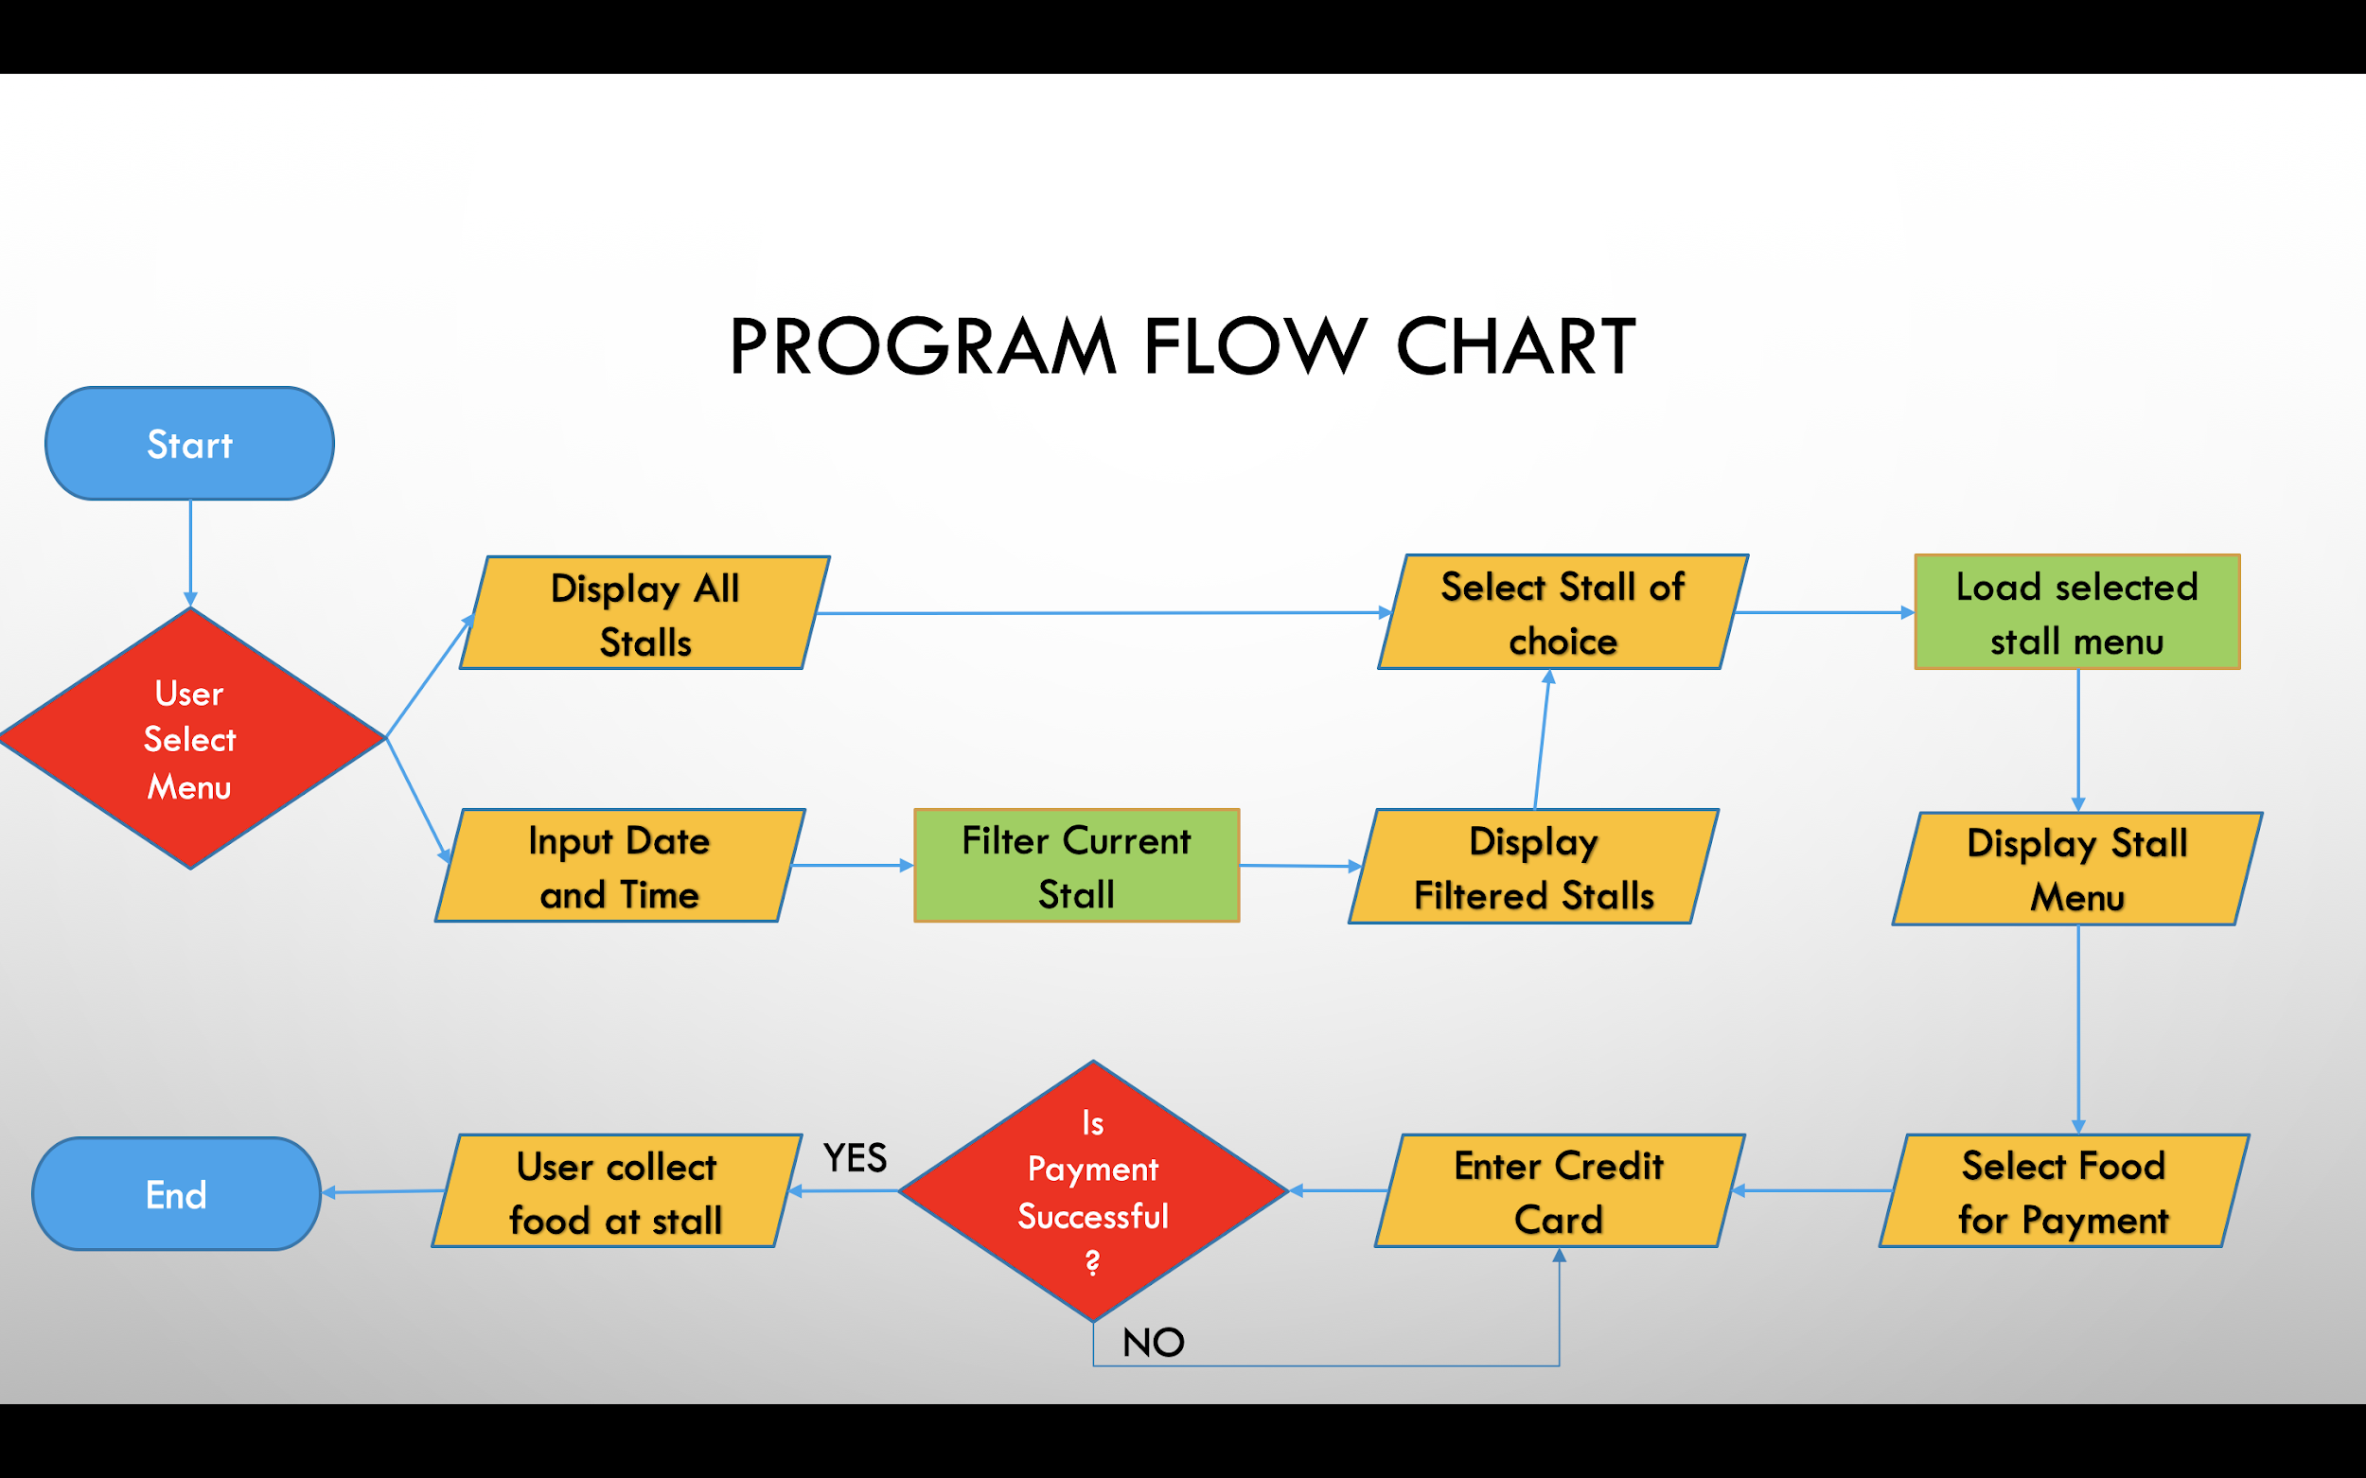

**Algorithm Design**

**A. Store and display stall information**

When a user first enters the stall page, all the information of the stalls listed will be displayed to them.

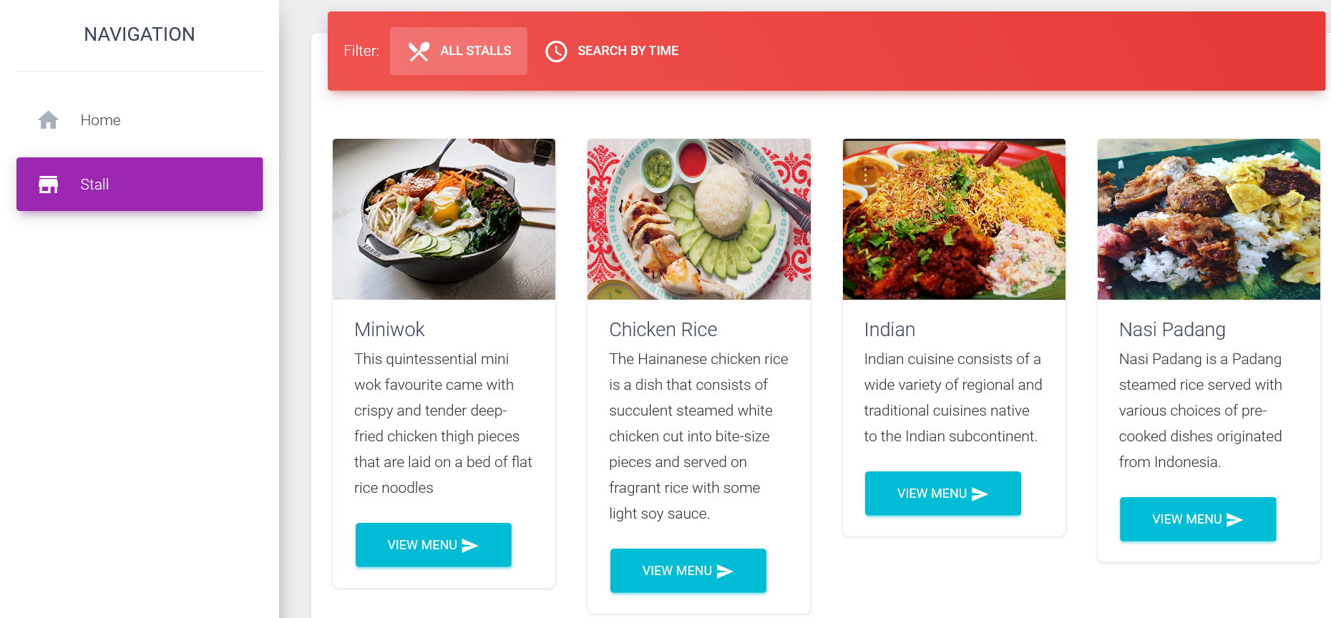

Figure 1: Displayed stall information

Stall information is stored in stall.json in a list.

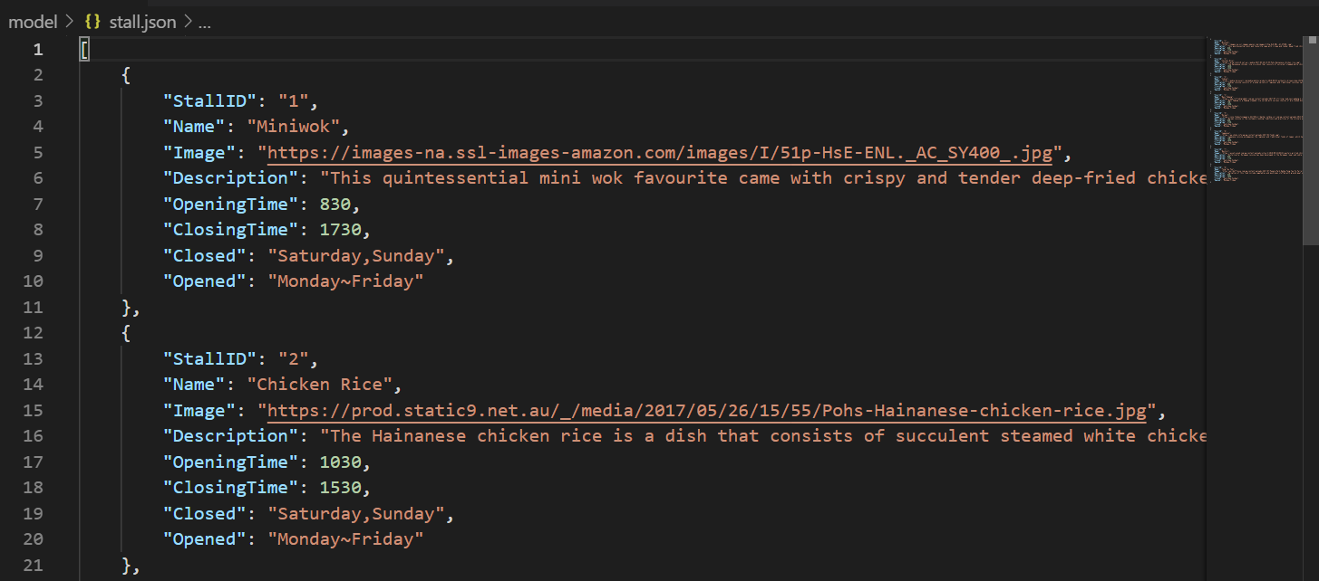

This information is then passed into stall.py to import the information into the main app.py file. The function to return the stall list to app.py, GetAllStall, is called by Stall = GetAllStall().

The information is then passed to the /stall html page using request.method ‘GET’, and displayed on the page.

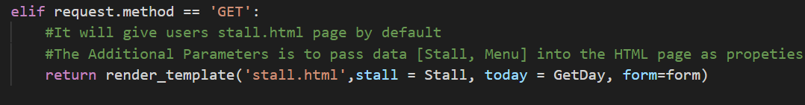

**B. Store and display stall menus**

Each of the stalls displayed on the /stall page has a “view menu” button. When the user presses one of the buttons, the user is directed to a /menu/StallID page, where StallID is the number associated with the stall. Then, the menu with the same StallID number will display, and the menu for that particular stall is displayed to the user on the page.

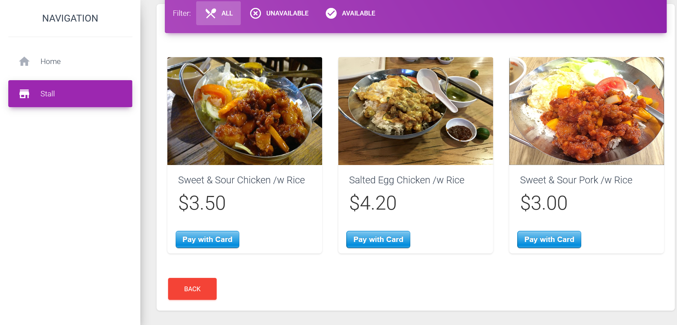

Fig 2. Menu information is stored in menuitems.json. The menus are put in a list as dictionaries.

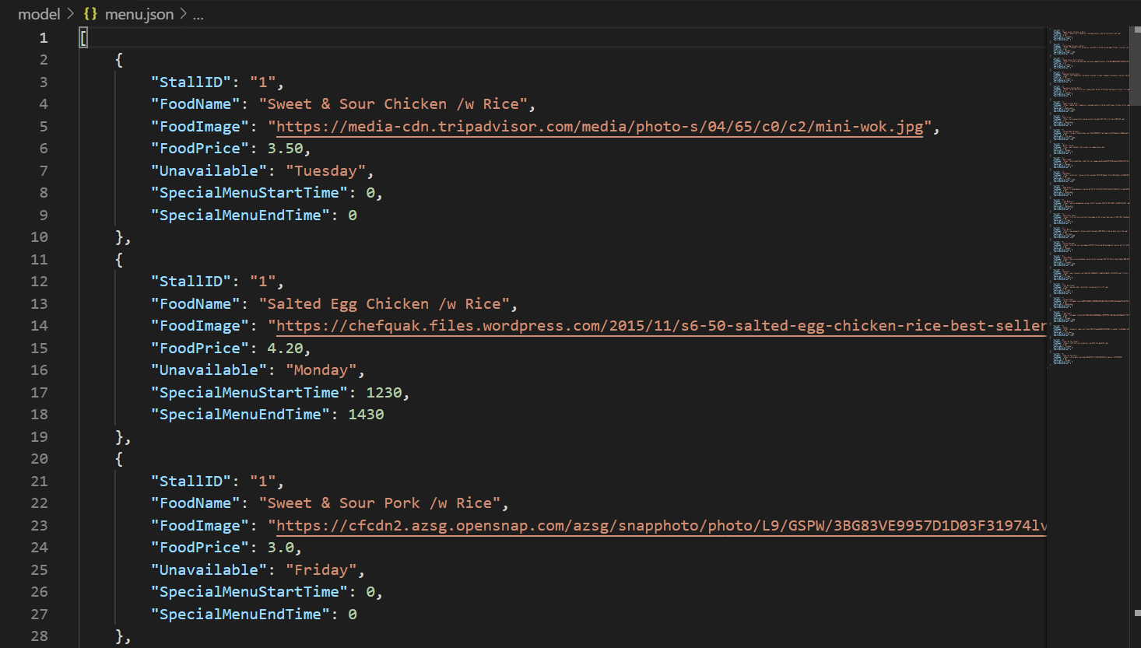

The information is then passed to menuitems.py. To ensure that only the menu of a stall displays without menu items from other stalls, the function StallMenu is used. StallMenu(stallid) filters menu items by only adding items that have the same StallID as the stall.

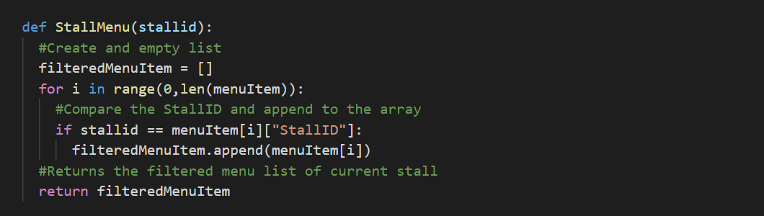

menuitems.py is then imported into app.py. The function to obtain the menu items by stall is called by MenuItems = StallMenu(id). The information is then passed to the /menu html page.

**C. Display stall information and menus based on the current system date and time**

Based on the current date and time, the user can view the menu of each stall to see the dishes available and unavailable at that time.

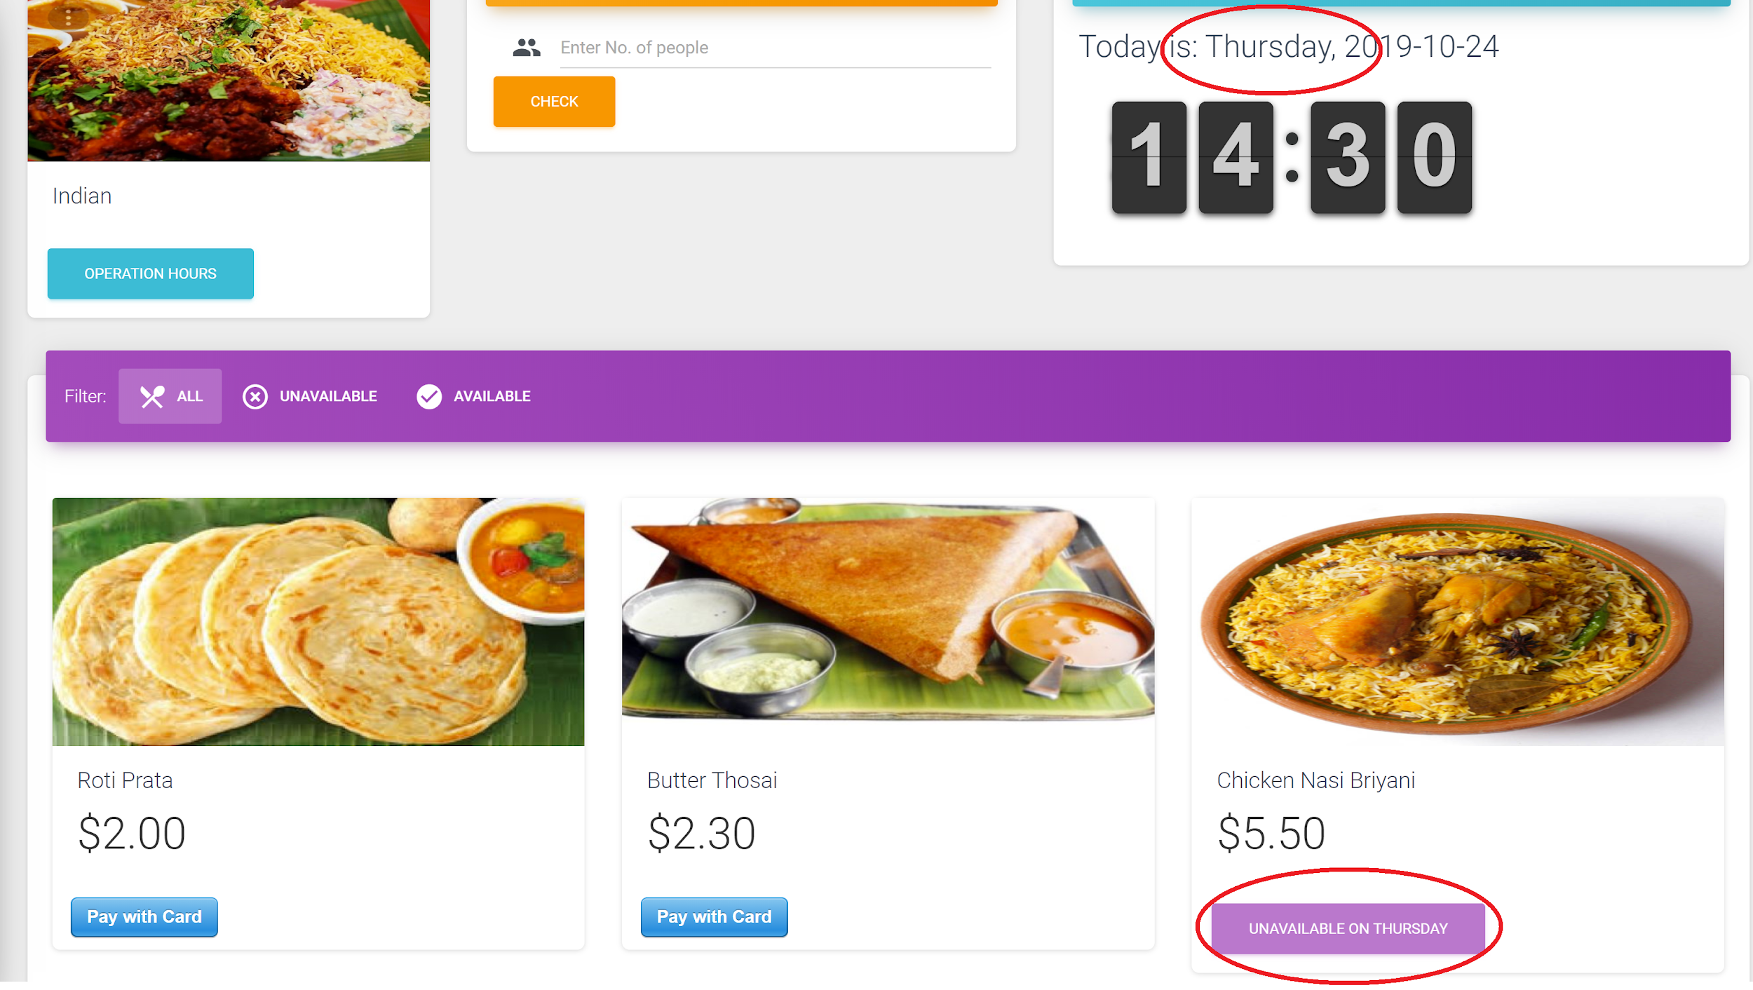

Figure: Menu available and unavailable based on the current date and time

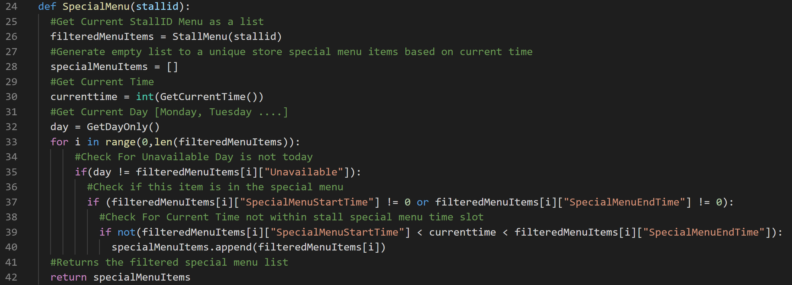

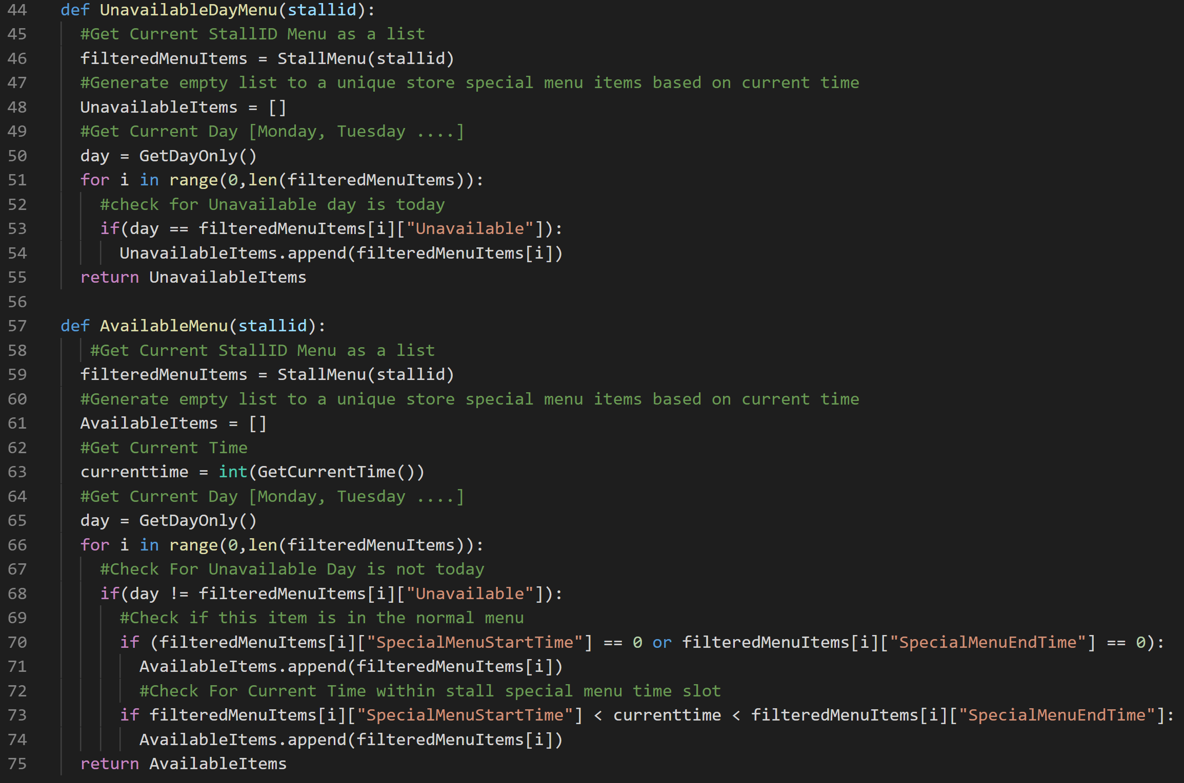

At the menu page of a particular stall, its menu will be rendered on the page. Based on the above 3 defined functions in menuitems.py, we are able to obtain the stall’s special menu as well as the menu that is unavailable and available based on the current time and date. The 3 arrays of special, unavailable and available menu items returned are then displayed and reflected correctly on the browser.

**D. Display stall information and menus based on user-defined date and time**

In the Stall page, users can switch to the “Search By Time” tab to view a form. This form receives two inputs from the user, the date and time, and displays the stalls that are open during that user-specified period.

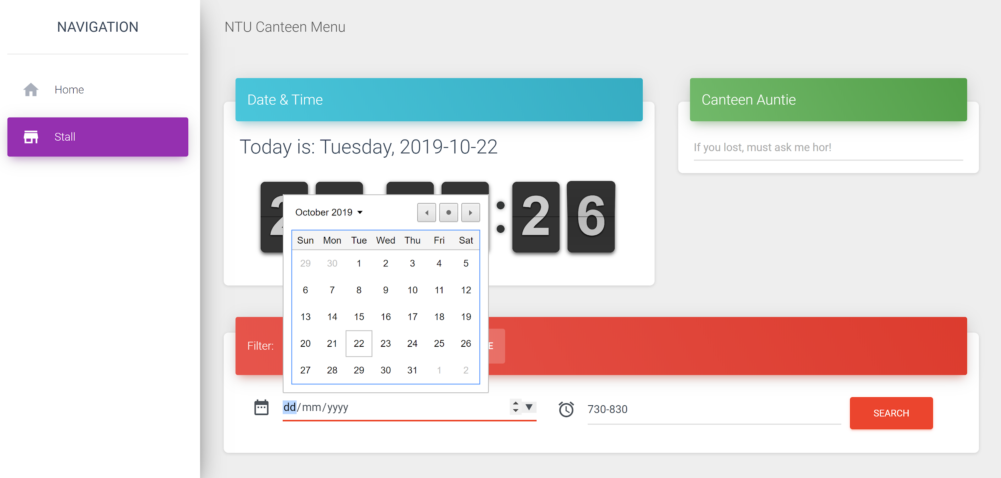

Figure 1: Selecting a date

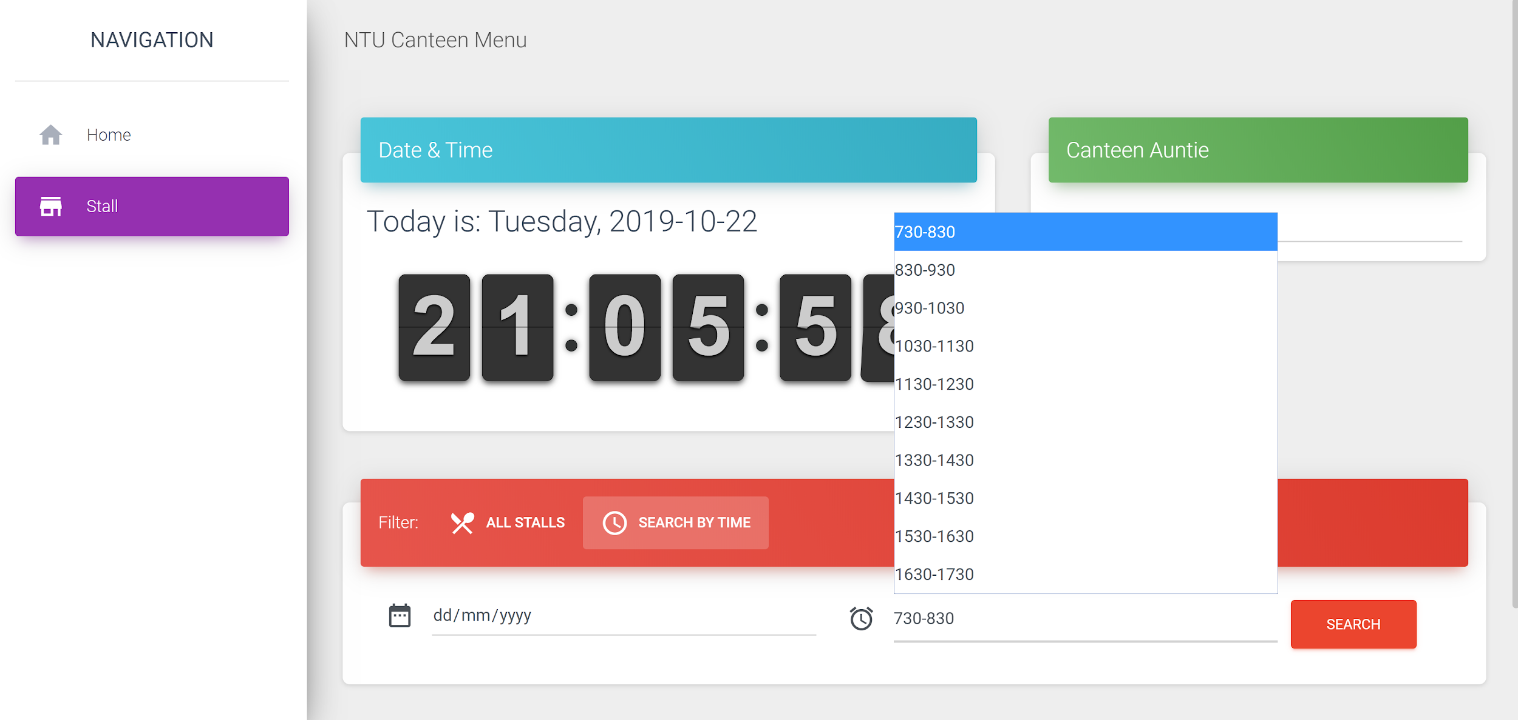

Figure 2: Selecting a time slot

The form template is designed in the SearchStallByDate.py file which is then imported into the main app.py file. With the help of the wtforms module, we created a SearchStallByDate class with two inputs, one that is a Date Field which allows users to choose a specific date and the other is a Select Field where users can select a timeslot from the dropdown menu.

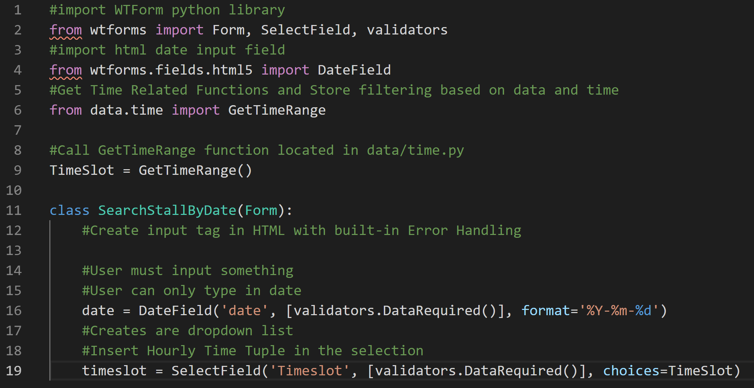

Figure 3: SearchStallByDate.py form

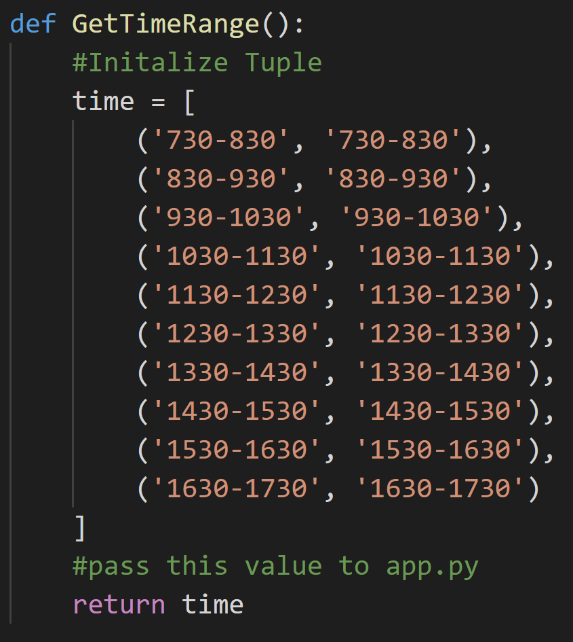

Figure 4: GetTimeRange() function

By submitting the form, a POST request is made to the server along with the user’s inputs. In this POST route, we capture the user’s input of **date** and **timeslot** and run the QueryStallByTimeSlot function which we have defined and imported from stall.py.

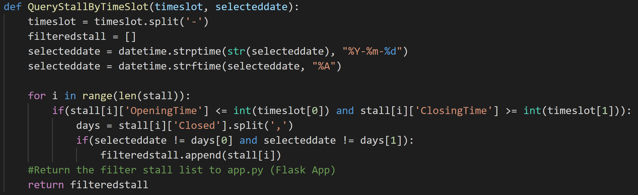

Figure 5: QueryStallByTimeSlot() function

The QueryStallByTimeSlot function takes two arguments: the user-defined timeslot and date. It creates a datetime object from the date given and then converts it to a string of the given day eg “Monday”. It then runs a for loop through the list of stalls and checks for each stall whether it is closed on that given day and if the timeslot chosen is within its opening hours. If the stall is not closed in that time period, it will be appended to an empty list **filteredstall**.

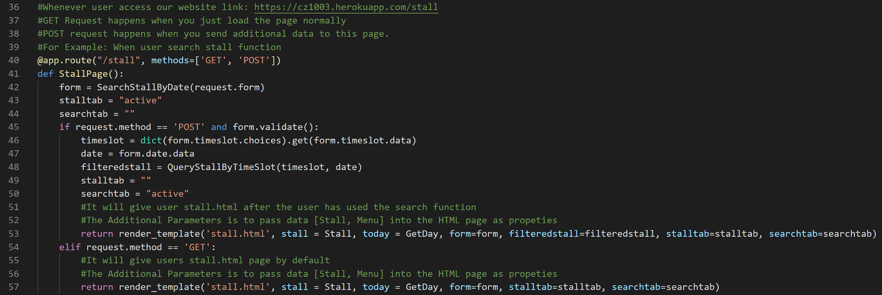

Figure 6: “/stall” route

This filteredstall list containing all the stalls that are open will then be sent to the browser, thus displaying stall information based on the user-defined date and time.

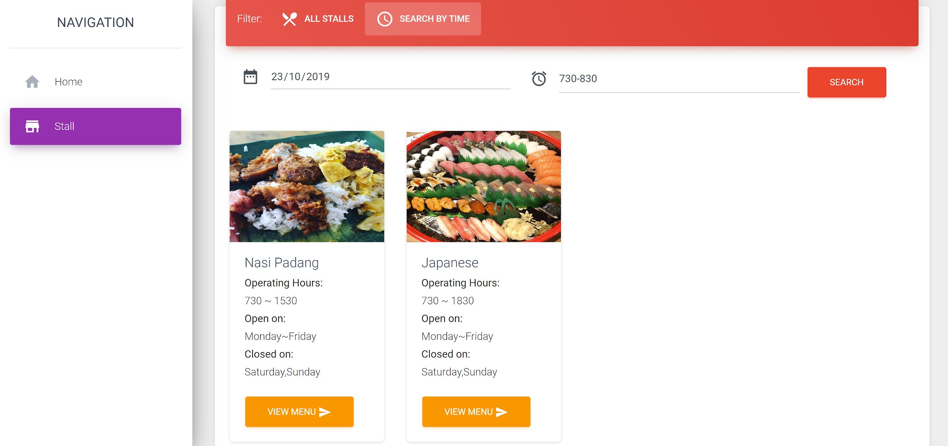

Figure 7: Filtered (available) stalls based on user inputs

Next, the users can then proceed to select the “View Menu” button for the stall of their choice to view the dishes available.

**E. Calculate estimated waiting time for the stall by asking user to enter the number of people in the queue**

After selecting “View Menu” for a particular stall, the user is brought to the stall’s menu page. Here, there is a form where the user can input the number of people in the queue to determine the estimated waiting time.

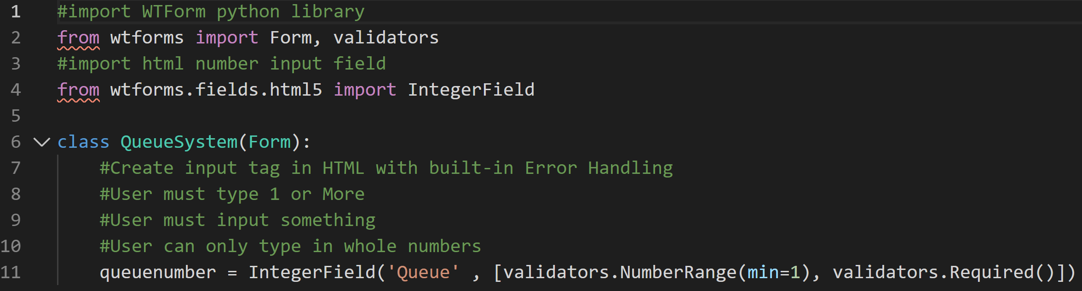

Figure 8: QueueSystem Form in QueueSystem.py file

By utilizing the wtforms module, we have created a form that takes one input from the user. With the validators included in the form, the user can only input an integer greater than or equal to 1.

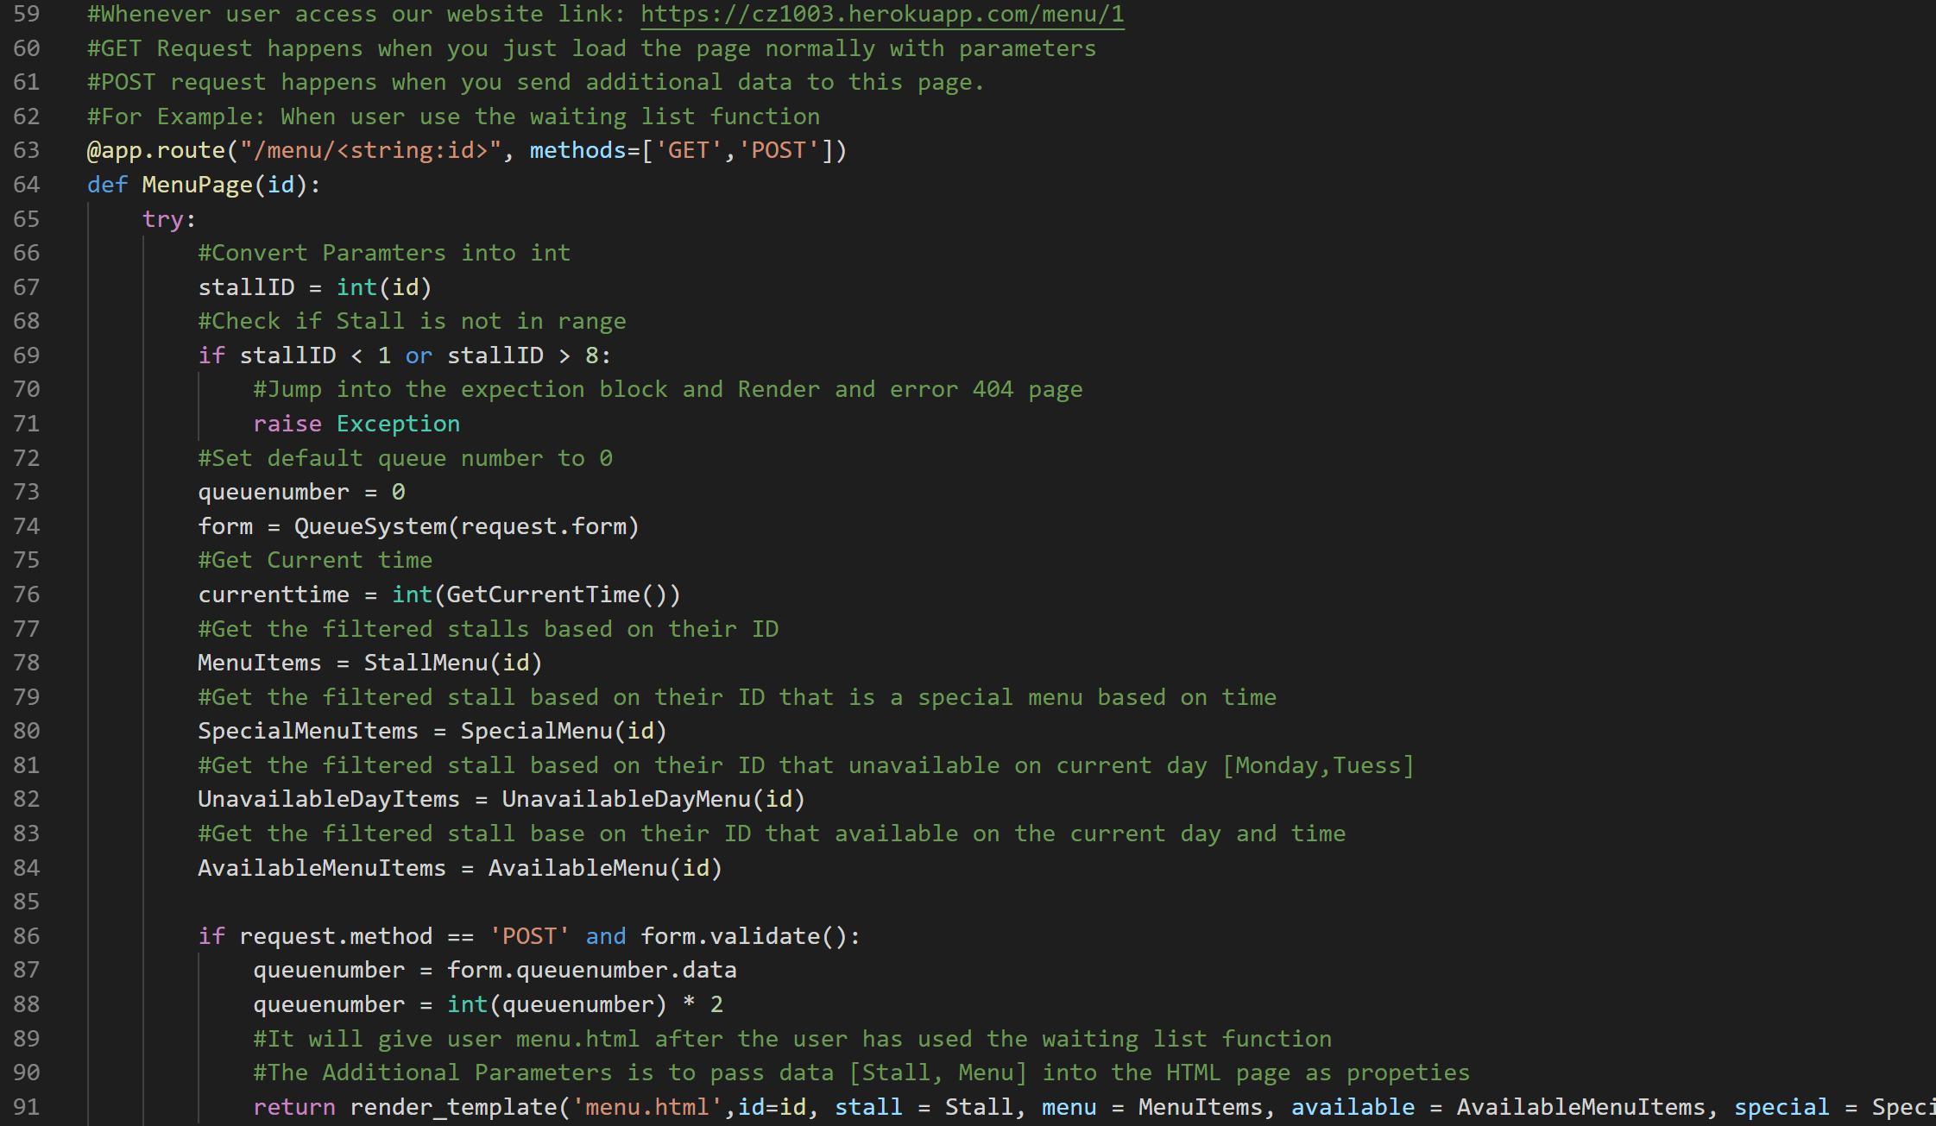

Figure 9: “/menu/<string:id>” POST route

Again, when the user submits an input to the form, a POST request is made and his input is received by the server. The user’s input is captured as **queuenumber**, which int() value is multiplied by 2 to obtain an estimate of the waiting time. This waiting time will then be sent to the client-side and displayed when we pass this updated **queuenumber** to the browser when we call render_template().

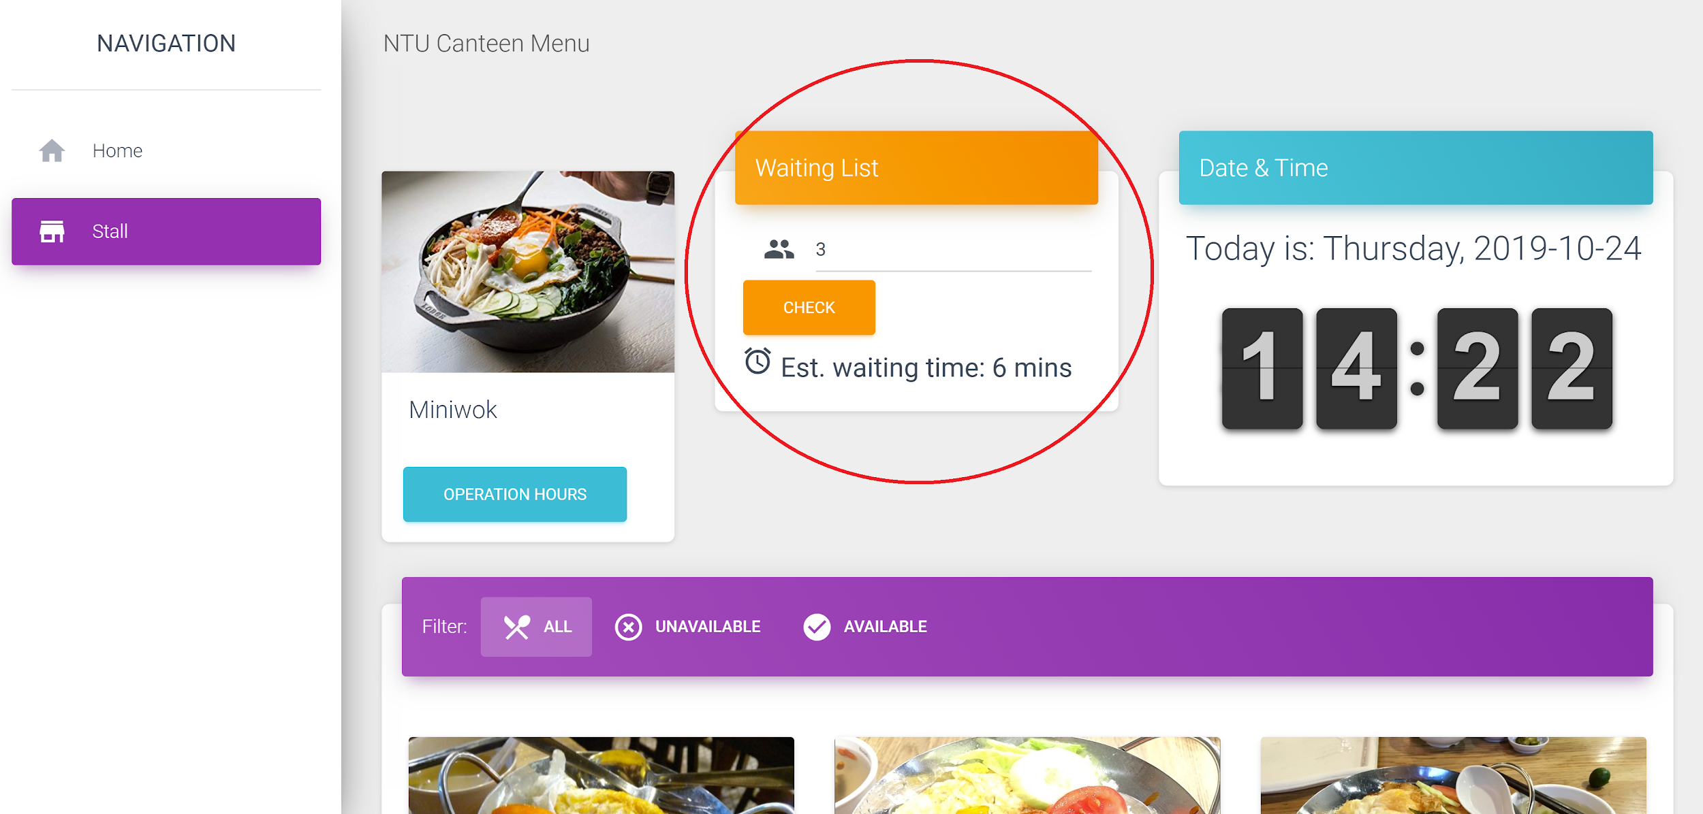

Figure 10: Estimated waiting time displayed when the user inputs the number of people in the queue

**F. Allow to check the operating hours for all stalls**

In the /menu page of a specific stall, users can check the operating hours of the stall by pressing on the “Operation Hours” button under the stall name. This will display the operating times of the stalls as well as the days these stalls are open.

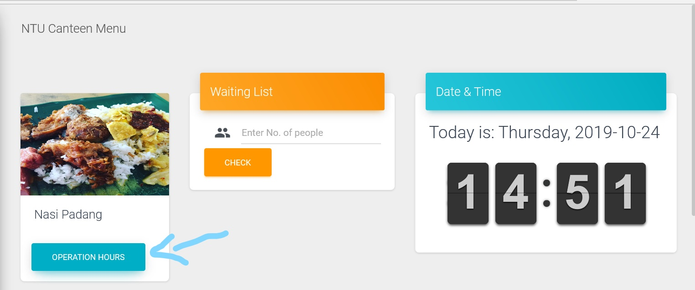

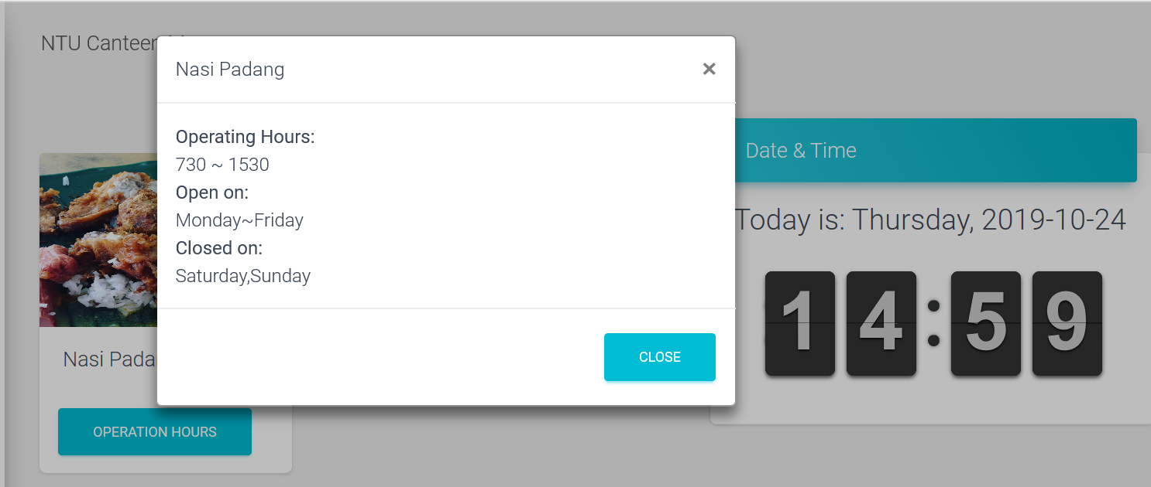

Information for the opening hours of each stall is stored with the stall information in stall.json.

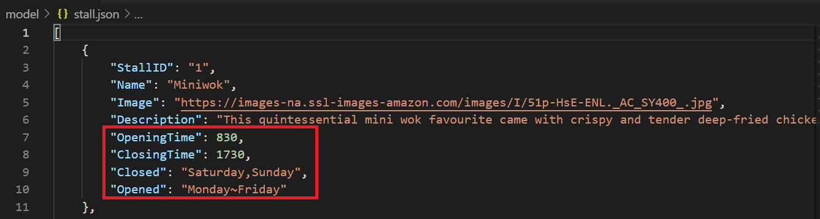

Stall information is passed to stall.py, which is then imported into the main app.py file, and called with Stall = GetAllStall(). The corresponding stall information is then passed into the html “menu” file. When the “Operation Hours” button is pressed, the system retrieves the data for the opening hours of the stall.

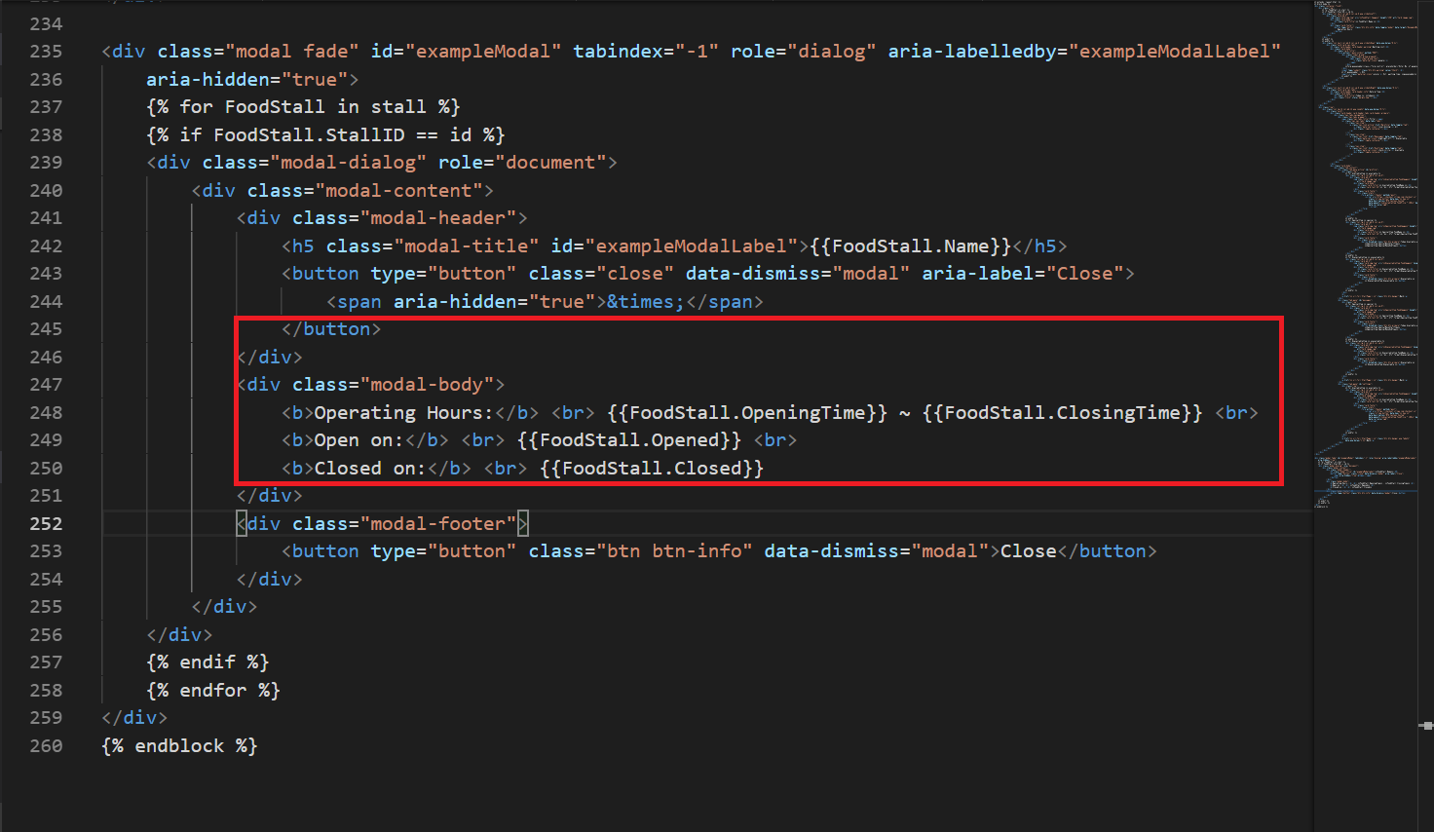

**Program Testing: Error Handling Test Cases**

1. WTForms Validation

The validators used with the forms will only allow a correct input from the user, otherwise, the form will continue to prompt for the correct input format.

1. Error page

If the user tries to visit an unspecified route, they will be directed to an error page. After this, they will be redirected to the stalls page.

1. Try-Except block

If the user tries to visit a stall menu page with stall id out of range, the try block will raise an exception and they will be redirected to the error page.

**Reflections**

Iskandar:   
Python Flask is micro web framework that could be use both as an API and Model View Controller (MVC) workflow. With the current project, I was able to use to object oriented program (OOP) concept to decouple the functions into smaller functions.   
  
Firstly, the hardest part for me was to learn the basic Python programming language from scratch. Secondly, I find the python syntax seems a little difficult for me to get familiarize even with prior working experiences with other programming languages. Thirdly, when I hosted my python project on a server, it keeps crashing because python project requires a lot of memory (2GB~) on Heroku cloud server in order to run the project. Lastly, teaching my teammates how to use Flask framework to write python codes directly on HTML.

Amadeus:

Firstly, I learnt how to utilise modules which are rather new to me. I found this difficult at first as it involves trying to understand someone’s code, which was quite advanced, and I am a beginner myself. However, reading the documentation for the code makes things much easier as I am able to understand what the code does and will be able to use it in my program even if I do not fully understand how that code is implemented (abstraction).

Secondly, I learnt a new concept, Object-Oriented Programming. For example, we packed our data in json format and access the relevant information from it using various methods.

Benjamin:  
I learnt how to direct information from a python file using via the Flask framework and display the python values on a HTML web page. By defining modules to return information eg. GetAllStall() returns stall information, I could import information from .json files to the main app.py file, so it could be displayed on a website

The hardest part for me was understanding how to transfer information from a python file to html. I had problems understanding the ‘GET’ and ‘POST’ methods in the main app.py file, and how it helped to transfer information and function.